INTERMEDIATE SPANISH II
232SPN202.970; 21339
Spring 2023

Flex
In person: Sugar Grove Campus, Collins Hall (COL), Room 205; and/or
Zoom: https://waubonsee.zoom.us/j/97197578754?from=addon; and/or
Online: Canvas & VHL Supersite

Mondays and Wednesdays, 11:00 a.m. to 12:15 p.m.

Instructor Contact Information and Availability
Name and Title: Laura E. Ortiz, Ed.D.
Waubonsee Email: email@waubonsee.edu
Office Hours: Upon Request
Office Hour Location(s): Zoom Link
Phone Number: 630.466.XXXX
Preferred Contact Method: Email
Response Time: Within 24 hours on weekdays and 48 hours on weekends

Course Description
This course provides students advanced Spanish vocabulary when listening, speaking, reading and writing. Students will create projects on cultural topics using past, present, future, and conditional tenses. Students will learn to apply grammar structures to narrate relevant opinions, desires, or preferences in the present, past, future, and conditional tenses.

Recommended Prerequisite
SPN201 or three years of high school Spanish or its equivalent.

Illinois Articulation Initiative (IAI) Code
H1 900

Course Materials
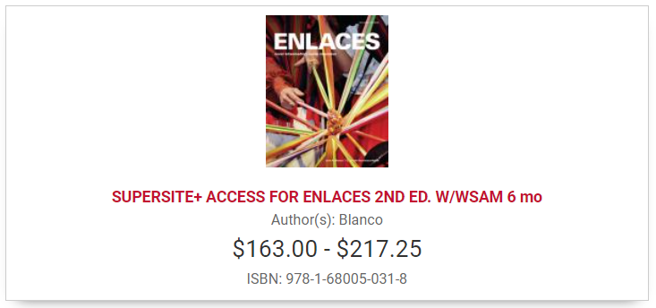
SUPERSITE+ ACCESS FOR ENLACES 2ND ED. W/WSAM 6 mo
Blanco. Enlaces (2nd Edition). Vista Higher Learning, ISBN: 978-1-68005-031-8

OR

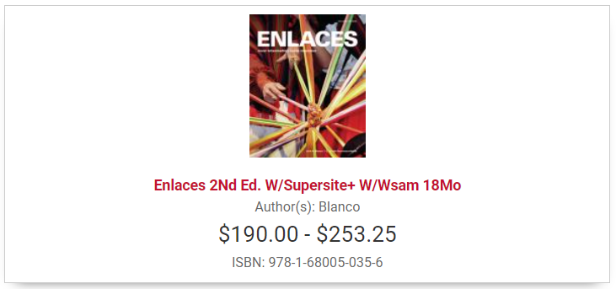
Enlaces 2Nd Ed. W/Supersite+ W/Wsam 18Mo
Blanco. Enlaces (2nd Edition). Vista Higher Learning, ISBN: 978-1-68005-035-6

Student Learning Outcomes

Course Learning Outcomes
Upon successful completion of this course, the student will be able to:
- Distinguish between present, past, future, and conditional tenses in Spanish contexts.
- Apply grammar structures in the present, past, future, and conditional tenses.
- Create a project using Spanish relevant opinions, desires, or preferences in the present, past, future, and conditional tenses.

Institutional Learning Outcomes
This course contributes to the following institutional learning outcomes:

☐ Critical Thinking
Examine information in order to propose or develop solutions or construct arguments.

☒ Communication
Use clear language to communicate meaning appropriate to various contexts and audiences.

☐ Quantitative Literacy
Make judgments or draw appropriate conclusions based on the quantitative analysis of data.

☒ Global Awareness
Describe the interconnectedness of issues, trends or systems using diverse perspectives.

☐ Information Literacy
Use technology to ethically research, evaluate or create information.

What is a FLEX Class?
Flex courses are delivered polysynchronously, which means there are multiple ways to attend class and learn the materials. You can choose to attend class in one of three ways: You can attend in person, attend class via Zoom, or watch a recorded video of the class later and complete the assignments on your own (this last option is called asynchronous learning). It is up to you! Each day, you can decide how you would like to attend class.
Here are a few reasons why you might choose the various options for attending class:
- In-Person: The benefit of in-person learning is that you are in the class with me—and your classmates! You can engage in discussions, ask questions, and participate in activities that help you learn the material. I will be in the classroom every day, and I will look forward to seeing you when you to attend in person!
- Zoom: The benefit of attending class using Zoom is that it offers you flexibility. You will still be present for the lectures, discussions, and activities. You can still ask questions and talk with classmates. The difference is that you will be able to do this remotely. Perhaps you aren’t able to get to campus because of transportation, family responsibilities, or illness. Zoom allows you to still participate in real time!
- Asynchronous Online Learning: I will record and upload our class lectures, discussions and activities each day, providing you with an opportunity to watch the videos later. I will also assign you the activities we did in-class. Again, this option provides you with flexibility. Perhaps transportation, work responsibilities, family commitments, or illness prevent you from participating during our class time. In those cases, you can still see what we did in class without falling behind!

- When you come to class in person, you will come to the Sugar Grove Campus, Collins Hall (COL), Room 205.
- When you attend via Zoom, you will use this Zoom meeting link: https://waubonsee.zoom.us/j/97197578754?from=addon
- When you attend asynchronously (meaning online, at a later time), you will access the class recording and assignments in Canvas.

Regardless of how you choose to participate in class, everyone will complete the same number of assignments.

Methods of Evaluation of Student Learning, Grading Criteria, and Scale
Your performance in this course will be evaluated based on the following components:

Percentage: Approximate Points:
Participation 15% 150 points: 30 sessions at 5 points each*
Supersite Assignments 15% 150 points: 12 weeks at 12.5 points/week
Journals 20% 200 points: 6 entries at 33 points each
Quizzes 10% 100 points: 3 quizzes at 33 points each
Exams 20% 200 points: 3 exams at 65 points each
Midterm Oral Exam 10% 100 points: 1 oral exam at 100 points
Final Project and Presentation 10% 100 points: 1 final project and presentation
TOTAL: 100% 1,000 points

*There are 31 class sessions this semester; therefore, everyone earns 5 free participation points.

90 to 100% 900-1,000 points A
80 to 89% 800-899 points B
70 to 79% 700-799 points C
60 to 69% 600-699 points D
59% and below 599 points or below F

Description and Details of Assignments

Participation
Participation is an important component of learning a language, and your participation will affect your course grade. Since this is a Flex class, you have three ways to earn your participation points: In-person in COL 205, synchronously through Zoom, or asynchronously by watching the recorded Zoom class sessions and completing the activities we did during class. These will be assigned and completed in the VHL Supersite and/or discussion board. Participation is worth 15% of your final course grade.

Supersite Assignments
Online Supersite Activities # and Participation Activities for Asynchronous Online Students will be assigned for each lesson. These assignments will have a due date by them. No late work will be accepted. You have unlimited attempts to earn the score you desire on the assigned activities. Supersite assignments are worth 15% of your final course grade.

Journals
You will write 6 journal entries throughout the course. These writing assignments will reflect the course vocabulary, grammar, and cultural themes. Journals are worth 20% of your final course grade.

Quizzes
You will complete vocabulary and grammar quizzes in the Supersite. The quizzes will help you know if you are ready for the lesson test and help you target what you need to practice or study more. No late quizzes will be accepted without prior approval. Vocabulary and grammar quizzes are worth 10% of your final course grade.

Exams
You will have 3 lesson exams to complete in the Supersite. The goal of each exam is to assess the vocabulary, grammatical concepts, and cultural themes of each lesson. No late exams will be accepted without prior approval. Exams are worth 20% of your final course grade.

Midterm Oral Exam
You will have a Midterm Oral Interview with your instructor. The <<Midterm Oral Interview>> module in Canvas includes details about the midterm oral interview, the evaluation rubric and a study guide to help you prepare for it. The goal of the midterm oral interview is to discuss the main communicative topics using the grammar and vocabulary you acquired during the first half of the course. No late midterm oral interviews will be accepted. The Midterm Oral Interview is worth 10% of your final course grade.

Final Project and Presentation
Individuals or groups of 2-4 students will give presentations during finals week. Each individual or group will choose a topic related to one we have covered during the semester. The project portion will be an artifact to support the presentation (paper, report, brochure, poster, video, etc.). Presentations will be 10-15 minutes. They will be graded on the basis of pronunciation, comprehensibility, fluency, content, appeal, and accuracy of grammar and vocabulary. The Final Project and Presentation is worth 10% of your final course grade.

Extra Credit
You will be offered a variety of extra credit opportunities throughout the semester, and you can earn up to 25 extra credit points. The points that you earn by participating in these activities will be applied to your final course grade. If you discover a cultural event that focuses on the Hispanic culture and/or the Spanish language, please bring it to my attention so that it can be announced to the class as an extra credit opportunity. There may be in-class opportunities to earn extra credit as well.

Institutional Policy

Withdrawal
Waubonsee Community College reserves the right to administratively withdraw students who are not actively attending.
Students may withdraw themselves from this course until the date noted on the Tuition Refunds page.
*** Please see the Student Handbook for other course policies and procedures.

Institutional Statements

Academic Integrity
Waubonsee Community College believes that all members of the community (students, faculty, staff, and administrators) have a responsibility to participate in learning with honesty, respect, and integrity. We must commit to engage in learning both in and out of the classroom, value each member in our learning community, demonstrate original thought, and help foster ethical, open, safe learning environments for all. For more information, please see the Waubonsee Community College Plagiarism Statement section in the Student Handbook.

Accessibility and Disability Statement
Accessibility is a value of our institution. We are committed to creating environments that are welcoming and that support all students' learning. If you experience barriers to your learning in this course please notify the instructor as soon as possible to discuss options. Students who experience barriers due to disability may contact the Access Center for Disability Resources to begin this conversation or establish accommodations.

Plagiarism
Waubonsee firmly upholds sound principles of academic integrity and responsibility. Plagiarism and cheating are serious infractions of academic integrity, and, as such, are considered breaches of the Code of Student Conduct. If a student has violated this policy, I will report the infraction to the Dean for Student Success and Retention and the student may fail the assignment or the course, depending on the severity or the number of infractions.

Student Support Services and Resources
Waubonsee Community College is committed to your success, and has many free supports, services, and resources available to you. Please visit the Waubonsee Cares page for links to basic needs (food, shelter, safety, etc.) support and resources both on campus and in the community. Please see the Student Experience page for more information and to get connected with Academic Support, Career Development, Counseling and Advising, Disability Resources, Student Life, Student Services, Technical Assistance Center, the Veterans Program, and many more! If you’re not sure what type of assistance you need, please talk to me and I will help get you connected.

Course Schedule

Please check the current Waubonsee Academic Calendar for important dates.

Week (Date) | Topic | Quizzes/Assignments (Due Date)
1 (1/18) | Welcome, introductions, getting started, and our community agreement | - Secure course materials and enroll in the VHL Central Supersite  - Preview: Enlaces, pages 120-129  Sunday, January 22 by 11:59 p.m.
2 (1/23 & 1/25) | Lesson 4: Perspectivas laborales  Cortometraje: Recursos Humanos  Para Empezar  Vocabulario | - Supersite Activities #1 and Participation Activities for Asynchronous Online Students  - Journal #1  Sunday, January 29 by 11:59 p.m.
3 (1/30 & 2/1) | Lesson 4: Perspectivas laborales  Imagina: Colombia, Ecuador, y Venezuela  The future and the conditional | - Supersite Activities #2 and Participation Activities for Asynchronous Online Students  - Quiz 1, Lesson 4  Sunday, February 5 by 11:59 p.m.
4 (2/6 & 2/8) | Lesson 4: Perspectivas laborales  Cultura: Recursos naturales: una salida al mundo  Comparatives and superlatives | - Supersite Activities #3 and Participation Activities for Asynchronous Online Students  - Journal #2  Sunday, February 12 by 11:59 p.m.
5 (2/13 & 2/15) | Lesson 4: Perspectivas laborales  Literatura: La intrusa  The present perfect and the past perfect | - Supersite Activities #4 and Participation Activities for Asynchronous Online Students  - Lesson 4 Exam  Sunday, February 19 by 11:59 p.m.
6 (2/20 & 2/22) | Lesson 5: El valor de las ideas  Cortometraje: Hiyab  Para Empezar  Vocabulario | - Supersite Activities #5 and Participation Activities for Asynchronous Online Students  - Journal #3  Sunday, February 26 by 11:59 p.m.
7 (2/27 & 3/1) | Lesson 5: El valor de las ideas  Imagina: La carretera Panamericana  The past subjunctive  The future perfect and the conditional perfect | - Supersite Activities #6 and Participation Activities for Asynchronous Online Students  - Quiz 2, Lesson 5  Sunday, March 5 by 11:59 p.m.
8 (3/6 & 3/8) | Midterm Oral Exams | - Per schedule on 3/6 & 3/8 during class time for in-person and Zoom students. Appointments for Asynchronous Online Students.  - Journal #4  Sunday, March 12 by 11:59 p.m.
9 (3/13 & 3/15) | No hay clase esta semana – ¡Vacaciones de primavera! | No hay tarea – que descansen y gocen de sus vacaciones .  Sunday, March 19 by 11:59 p.m.
10 (3/20 & 3/22) | Lesson 5: El valor de las ideas  Cultura: Chile: dictadura y democracia  Negative, affirmative, and indefinite expressions | - Supersite Activities #7 and Participation Activities for Asynchronous Online Students  - Lesson 5 Exam  Sunday, March 26 by 11:59 p.m.
11 (3/27 & 3/29) | Lesson 6: Herencia y destino  Cortometraje: El tiple  Para Empezar  Vocabulario | - Supersite Activities #8 and Participation Activities for Asynchronous Online Students  Sunday, April 2 by 11:59 p.m.
12 (4/3 & 4/5) | Lesson 6: Herencia y destino  Imagina: ¿Qué sabes de España?  The passive voice and constructions with se | - Supersite Activities #9 and Participation Activities for Asynchronous Online Students  - Journal #5  Sunday, April 9 by 11:59 p.m.
13 (4/10 & 4/12) | Lesson 6: Herencia y destino  The present and past perfect subjunctive | - Supersite Activities #10 and Participation Activities for Asynchronous Online Students  - Quiz 3  Sunday, April 16 by 11:59 p.m.
14 (4/17 & 4/19) | Lesson 6: Herencia y destino  Si clauses  Cultura: La ciudad redescubierta | - Supersite Activities #11 and Participation Activities for Asynchronous Online Students  - Journal #6  Sunday, April 23 by 11:59 p.m.
15 (4/24 & 4/26) | Lesson 6: Herencia y destino  Literatura: Algo muy grave va a suceder en este pueblo  In-class Work Session | - Supersite Activities #12 and Participation Activities for Asynchronous Online Students  - Lesson 6 Exam  Sunday, April 30 by 11:59 p.m.
16 (5/1 & 5/3) | In-class Work Session (5/1)  Final Projects & Presentations (5/3) | Per schedule on 5/3 during class time for in-person and Zoom students. Video Presentations for Asynchronous Online Students.
17 (5/8 & 5/10) | Final Projects & Presentations (5/8)  End-of-semester Celebration (5/10) | Per schedule on 5/8 & 5/10 during class time for in-person and Zoom students. Video Presentations for Asynchronous Online Students.

